Annual Die Hard Regatta

MC Fleet # 42
Lake Harriet Yacht Club
Minneapolis, MN
September 12-13, 2015

SAILING INSTRUCTIONS

1. RULES

The regatta will be governed by the rules as defined in the current Racing Rules of Sailing (RRS). In case of conflict these Sailing Instructions (SI) will prevail. It is classified as a Category A event in accordance with ISAF Regulation 20.

- ELIGIBILITY AND ENTRY

The regatta is open to all boats of the MC, C, and M16 class. Entries must be completed and all fees paid by close of registration for a boat to be scored. All MC class boats must comply with the MC Sailing Association (MCSA) scantlings prior to the preparatory signal of the first scheduled race. A boat may sail with a different sail number from its hull number if it registers with that sail number, and must compete with that number for the entire event.

3. NOTICES TO COMPETITORS

Notices to competitors will be posted on the Official Notice Board located at the LHYC shed information case.

4. CHANGES TO THE SAILING INSTRUCTIONS

Any changes to the Sailing Instructions will be posted at the completion of the Competitors’ Briefing Meeting on the first day or two (2) hours before the scheduled time of the warning signal of the first race on Sunday. Changes to the schedule of races may be announced and posted during Saturday’s lunch break or posted no later than 1900 hours the day before it will take effect.

5. COMPETITORS’ BRIEFING MEETING

Saturday, September 12, 2015 at 09:00 hours, at the LHYC Dock.

6. SIGNALS MADE ASHORE

Signals made ashore will be displayed at the LHYC Dock or docked signal boat.

Approximately 30 minutes prior to the scheduled warning signal, the signal boat will fire a gun, or make another sound signal.

When a postponement is signaled ashore (two sound signals), the next warning signal will be made not less than 30 minutes after the lowering of flag “AP”. One sound signal will be made when “AP” is lowered.

7. SCHEDULE OF EVENTS

Friday, September 11 1700-2000 Registration and Welcome

Saturday, September 12 0730-0900 Registration and Breakfast
0900 Competitors’ Briefing Meeting
1000 Warning Signal Race 1; Race 2 immediately
Following at the discretion of the Race Committee
TBD LUNCH
TBD Warning Signal for additional races at the discretion
of the Race Committee
1830 Dinner and party.

Sunday, September 13 0930 Warning Signal 1st race of day; additional race(s) at

the discretion of the Race Committee

NO RACE WILL START AFTER 12:00 hours

Trophy presentation 1 hour after final race

8. RACING AREA

The racing area will be identified by buoys visible from the dock.

9. ABANDONMENT AND SAFETY

When the safety of a race is threatened due to weather or other concerns after at least one boat has sailed the course and finished within the time limit, the Race Committee (RC) may abandon the race. In this situation, flag “N over H” means “discontinue racing and find safe harbor”.

Any boats that have not finished may be scored at the discretion of the Principal Race Officer (PRO) who may also order the race abandoned. This changes RRS 32 and 35 and the Race Signal for flag “N over H”.

No race will be started when the wind registers 20 mph steady or gusts 23 mph and higher as measured on the RC boat. If, after a race has started, the wind registers 20 mph steady or 23 mph in gusts, the RC will either abandon the race or shorten the course at the next possible mark and take finishes there.

10. THE COURSES

The RC Signal Boat will display the course to be sailed with a letter and numbers. For example, the letter “W” indicates the course configuration (Windward/Leeward). The first number indicates the number of complete and partial laps to be sailed. All marks shall be rounded as indicated by the background color of the course designation plaques.

The Course length will be a distance such that a race can be completed in 50 minutes +/- 10 minutes.

A boat observed by the RC to violate rule 28.1 (Sailing the Course) shall be scored DNF by the RC without a protest or hearing. This changes RRS 61.1, 63.1, 69.1, and A5.

The courses shall be either Windward-Leeward or Olympic configurations as illustrated below:

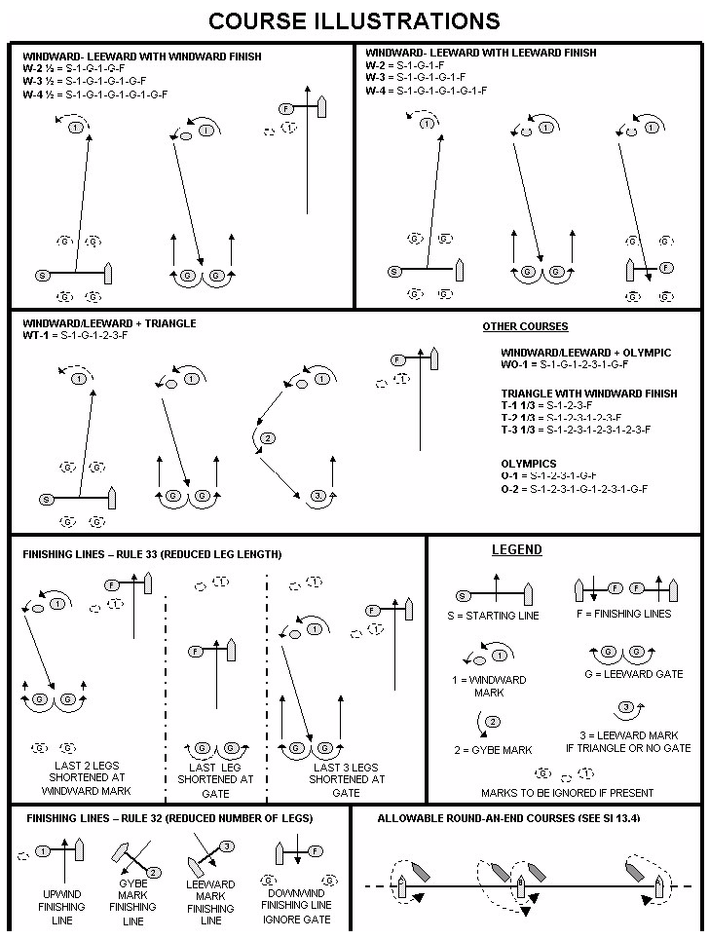

11. MARKS

Original marks will be orange or yellow spheres and the offset mark will be a small orange sphere. An offset will be placed at the windward mark for Windward-Leeward configurations only. A leeward Gate may be used on Windward-Leeward courses.

New marks, when used in accordance with RRS 33 (Changing the Next Leg of the Course), will be identified by the PRO or safety boat personnel.

After the start, minor adjustments in a mark’s location will not be signaled. This changes RRS 33. Significant changes in course shall be signaled from the RC boat or official chase boat stationed at the preceding mark. A red or green flag displayed in conjunction with Flag “C” indicates the new mark is located to port or starboard of the original respectively. Periodic horns or whistles will accompany this notification.

12. THE START

Races shall be started in accordance with RRS 26 (5 minute start). The Class flag will be an MC, M-16, or C or class burgee. Approximately one minute prior to the warning signal, a series of short horn bursts will sound.

The starting line will be between the staff displaying the RC flag on the Race Committee boat at the starboard end and a buoy displayed on the port end.

RRS 30.1 (I Flag Rule) will be in effect on all starts. This changes Race Signals.

A boat attempting to start more than 5 minutes after her starting signal shall be scored DNS.

13. RECALLS

Following the display of the individual recall signal, the RC will attempt to announce by VHF radio and/or hailer the sail numbers of all boats identified on the course side of the starting line at the start signal. Such announcements are a courtesy and failure by the RC to make the announcement, or of boats to hear and/or understand it, shall not constitute grounds for redress. This supplements RRS 62.1(a).

14. BLACK & Z FLAG RULES

RRS 30.2, 30.3, and 36 are changed as follows:

After the start, boats that have not complied with RRS 30.3 will be notified by VHF radio or hail. After receiving notification, such boats shall keep clear of all other boats unless they intend to act under RRS 60.1(b).

If a race is abandoned or a General Recall is signaled after the starting signal, all competitors who received a 20% scoring penalty under RRS 30.2 or were disqualified under RRS 30.3 in the abandoned race, are again eligible to race without penalty.

15. THE FINISH

The finishing line will be between a staff displaying the RC flag on the Race Committee boat at the starboard end and an orange or yellow buoy displayed on the port end. A white flag displayed by the RC in the finishing area indicates that another race will be started as soon as possible. This supplements RRS Appendix L, 12.3. Other course mark(s) remaining in the vicinity of the finishing line will have no required side for boats about to finish.

16. TIME LIMIT

The time limit shall be 75 minutes.

Boats still racing 20 minutes after the first boat sails the course and finishes will be scored FFW (Failed to Finish within Window), the position of the last boat to finish plus 2. This changes RRS 35, A4.2, and A11.

Any race in which no boat has rounded the first mark within 30 minutes of the starting signal shall be declared abandoned.

17. PROTESTS

As soon as possible after the race in which an alleged violation occurred, a protesting boat shall notify the RC of the racing number of all protested boats. This notification may be given to the RC boat in the finishing area.

Upon landing, the RC shall post the time of landing of the RC signal boat and the numbers of all known protesting and protested boats.

Protests shall be written on forms available at the LHYC Boat House and lodged with the PRO or other designated person within the protest time limit which is one hour after the landing of the RC signal boat.

The Protest Committee will post on the Official Notice Board the start time of the first hearing and the order in which other protests will be heard.

RRS 62.2 is changed in that the words “two hours” are replaced by “one hour”.

18. SCORING

The Low Point System, RRS A4, will apply. Six races are scheduled. There will be no throw-outs. This changes RRS A2. One race constitutes a regatta for purposes of awarding keeper trophies. A boat skippered by multiple sailors shall be scored as one team if so registered.

Trophies will be awarded to the first seven finishers in the MC class and to top finishers in other classes to be determined.

19. OUTSIDE HELP
A boat that receives outside help from any source other than that permitted by RRS 41 shall retire. This supplements RRS 41.
20. RADIO USE
A hailer will be the primary means used by the RC to communicate with competitors. In addition to announcing times during the starting sequence, the RC may share pertinent information with boats in the spirit of improving the safety and quality of racing. The channel to be used will be posted. VHF radio communication may be used in addition at the discretion of the PRO.
The only communication devices that may be used by competitors when racing are: a) a weather monitor, b) a VHF radio tuned to receive only RC transmissions that are intended for all boats and c) a cell phone that may be used for emergency purposes only.
Failure to hear a hale or an RC transmission shall not constitute grounds for redress. Except to make a required report or in an emergency, no transmission shall be made to the RC or other person when racing.
The penalty for breaking this rule will be total disqualification from the regatta or such lesser penalty as may be determined by the Protest Committee.

